Assignment 6
Topic: Queue-Based Ticketing System

Name: Soham Ajit Puri
Roll. No: 04
Branch: CSDS_C1

Problem Statement: Design a queue-based ticketing system (like in banks or hospitals) where people are served in order.

Algorithm:
Step 1: Start

Step 2: Initialize the system:
- Create a ServiceDesk object called counter.
- Set currentToken = 1.
- Initialize an empty queue waitingList.
- Set menuChoice = 0.

Step 3: Display Menu in a loop until user chooses Exit (4):
- Show the following options:
[1]Get Token
[2]Serve Next
[3]Show Waiting Tokens
[4]Exit
- Read user input into menuChoice.

Step 4: Process the choice

If choice = 1 (Get Token):
- Generate a new token using giveToken().
- Display token number.
- Add token to waitingList.
- Increment currentToken.

If choice = 2 (Serve Next):
- Call callNext().
- If queue is empty, display "No one is waiting right now!".
- Otherwise, remove and display the first token in the queue.

If choice = 3 (Show Waiting Tokens):
- Call showWaitingList().
- If queue is empty, display "Waiting area is empty".
- Otherwise, display all tokens currently in the queue (without removing them).

If choice = 4 (Exit):
- Display “System closing.. Goodbye!”
- Exit the loop.

Step 5: End

CODE:

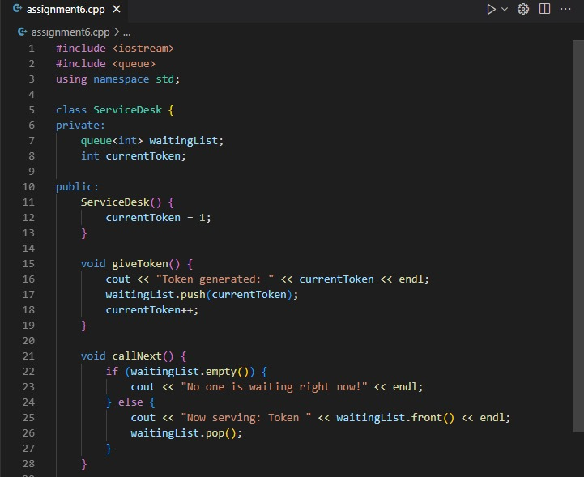

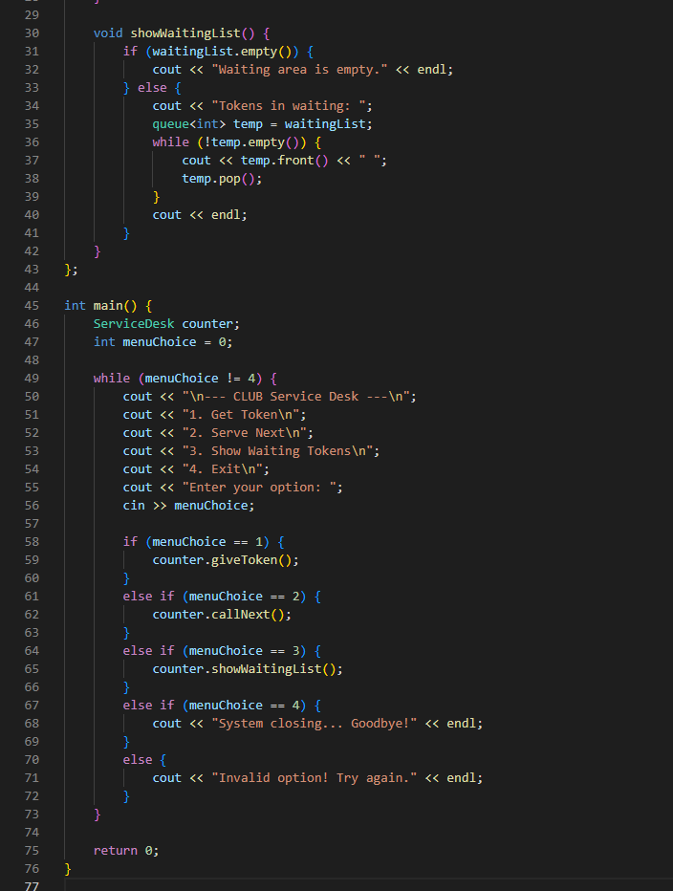

RESULTs:

- For the 1st option of “Get Token”
We generated 5 tokens for example:

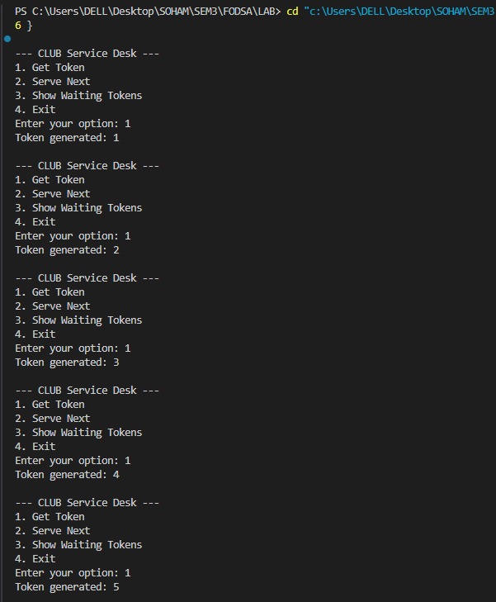

- For the “Serve Next” Section:

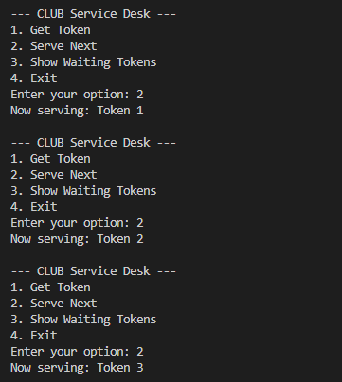
- For the “Show Waiting Tokens” output:

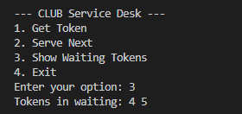

Conclusion:
This assignment was about designing and implementing a queue-based ticketing for Club Service system, similar to those used in banks and hospitals, where customers are served in the order they arrive. The program demonstrated the use of queues in C++ to generate tokens, serve customers sequentially using class and objects, and display the current waiting list, thereby showing how data structures can be applied to real-life service desk scenarios.

